Configure Your Pi

Regardless of whether you are using the full desktop or a headless setup, you will need to perform some basic configuration steps on your new Raspberry Pi installation. These steps can be easily performs from a *terminal* (a text input/output environment).

**Full Desktop:** You should be automatically logged into the X windows manager (otherwise known as the *desktop*). To open a terminal, simply click on the **Terminal** icon on the top left of the desktop. You should be immediately presented with a command prompt in a terminal window.

[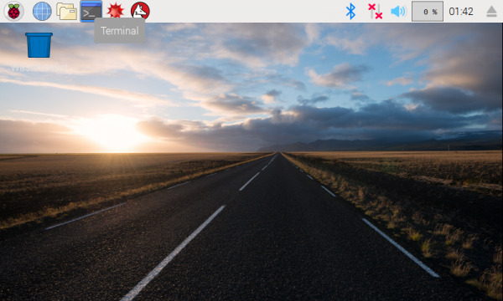](https://cdn.sparkfun.com/assets/learn_tutorials/7/8/3/screen_01.png)

**Headless:** With a headless setup, everything you do will be through a terminal. When you connect to your Pi through Serial or SSH, you will be presented with a login prompt on the terminal. Enter the default credentials:

* **Username:** pi
* **Password**: raspberry

You will be presented with a command prompt.

[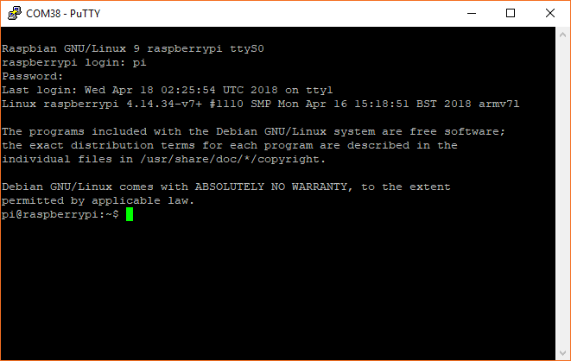](https://cdn.sparkfun.com/assets/learn_tutorials/7/8/3/terminal_01.png)

Run the Config Tool

From your command prompt, enter the command:

sudo raspi**-**config

If asked to enter a password, type out the default password: raspberry.

You will be given several options on how to configure your Raspberry Pi.

[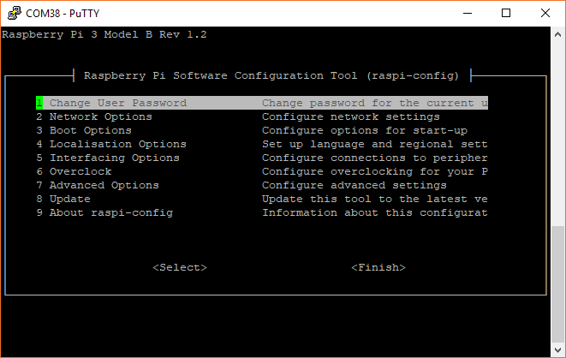](https://cdn.sparkfun.com/assets/learn_tutorials/7/8/3/terminal_02.png)

* Use the arrow keys to select **1 Change User Password** and follow the on-screen prompts to change your default password.

**Warning:** It is strongly recommended that you change your password. If you connect your Pi to a network and leave the password as 'raspberry', anyone with access to that network will be able to easily get into your Pi.

* Next, select **2 Network Options**
* In the following screen, select **N2 Wi-fi**, and follow the prompts to connect your Pi to a local WiFi network (assuming you have one available).

[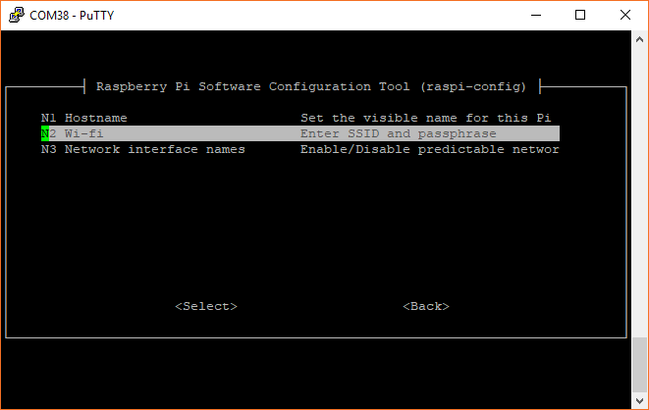](https://cdn.sparkfun.com/assets/learn_tutorials/7/8/3/terminal_03.png)

Select **4 Localisation Options** to bring up the keyboard and time zone options.

[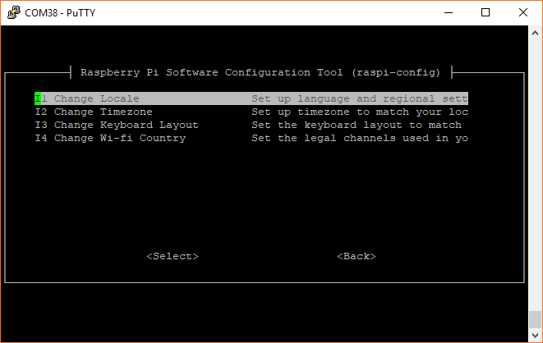](https://cdn.sparkfun.com/assets/learn_tutorials/7/8/3/terminal_04.png)

* Select **I1 Change Local**
* Scroll down to highlight **en_GB.UTF-8 UTF-8**, and press the spacebar to deselect it (the asterisk '*' will disappear)
* Scroll to find your language/country and press space to select it (an asterisk '*' will appear next to your selection)
* If you live in Great Britain, you can just leave **en_GB.UTF-8 UTF-8** selected
* If you live in the United States, you will probably want to select **en_US.UTF-8 UTF-8**.

[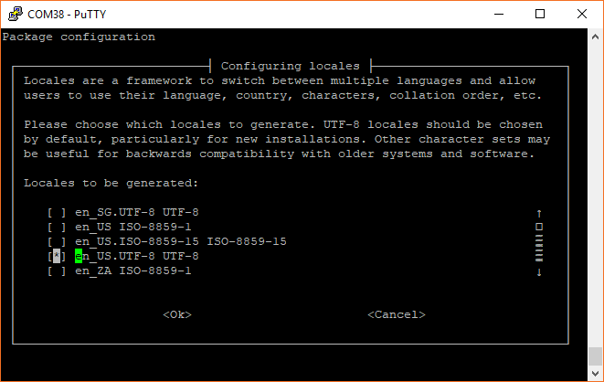](https://cdn.sparkfun.com/assets/learn_tutorials/7/8/3/terminal_05.png)

* Press *enter* to save the changes
* On the next screen, highlight your chosen localization option (e.g. **en_US.UTF-8** if you're in the United States) and press *enter*.

[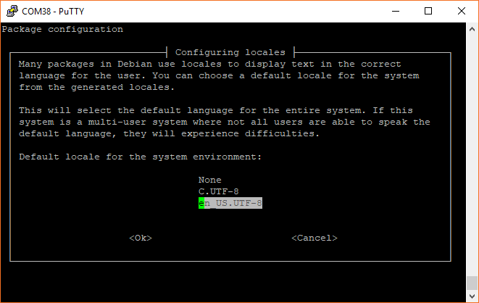](https://cdn.sparkfun.com/assets/learn_tutorials/7/8/3/terminal_06.png)

* Go back into the **4 Localisations Options**, and select **I2 Change Timezone**
* Follow the prompts to select your timezone.
* Back in **4 Localisations Options**, select **I3 Change Keyboard Layout**
* Choose your preferred layout (the default *Generic 105-key (Intl) PC* seems to work well in most situations)
* On the next screen, select the layout for your language/country
* If you live in Great Britain, you can leave **English (UK)** selected. Otherwise, select **Other**, press *enter*, and follow the prompts to select your language/country. If you live in the United States, select **English (US)**, and on the next screen, scroll up to highlight **English (US)**. Press *enter*.

[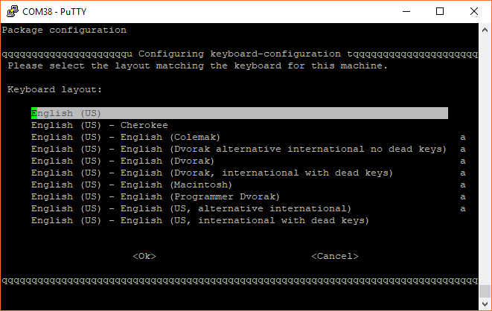](https://cdn.sparkfun.com/assets/learn_tutorials/7/8/3/terminal_07.png)

* Leave **The default for the keyboard layout** selected, and press *enter*
* Once again, leave the default **No compose key** selected, and press *enter*
* Leave *No* selected when asked about using *Control+Alt+Backspace*, and press *enter*
* After a few moments, you will be dropped back into the main Configuration Tool menu.

Select **5 Interfacing Options**.

[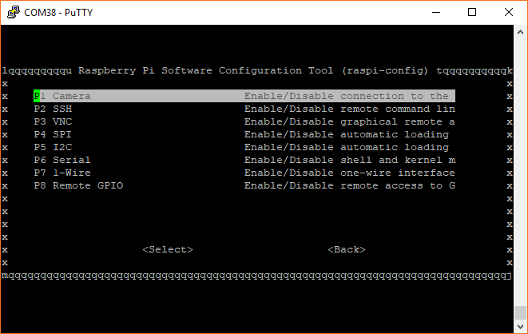](https://cdn.sparkfun.com/assets/learn_tutorials/7/8/3/terminal_08.png)

* Feel free to enable the *Camera* interface and *SSH* if you think you'll need them
* Select **SPI**, select **yes** on the following screen, press *enter*
* Repeat for **I2C**
* Repeat for **Serial**

Back in the main screen, select **7 Advanced Options**.

[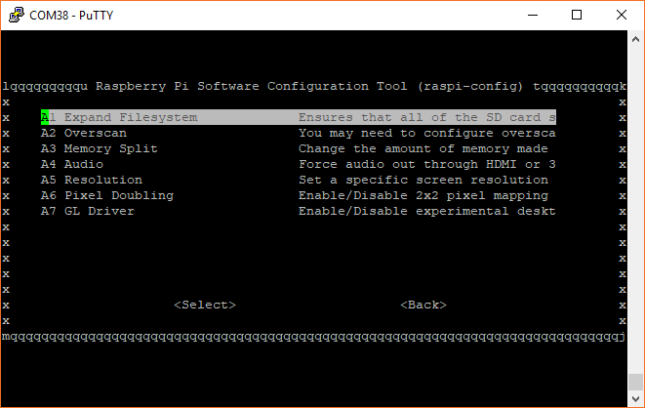](https://cdn.sparkfun.com/assets/learn_tutorials/7/8/3/terminal_09.png)

* Select **A1 Expand Filesystem**, and press *enter*
* Go back into **7 Advanced Options**, select **A4 Audio**, highlight **1 Force 3.5mm ('headphone') jack**, and press *enter*
* Use the *right arrow* key to select **Finish**, and press *enter*. If asked to reboot, select **Yes** and press *enter*. Wait while your Raspberry Pi restarts.

If you are using a Serial or SSH terminal, log back in using the username pi and the password you created earlier.

Use Python 3

By default, Raspbian (Stretch version April 2018 and earlier) uses Python 2. However, versions 2 and 3 come installed by default. We just have to make 1 minor change so that the Pi uses Python 3 whenever we type python into a terminal.

In a terminal window, enter the following command:

python **--**version

You should see which version is being used by default. For example, you might see Python 2.7.13. If you see that your OS is using Python 2 by default, you'll need to change it to use the Python 3 installation. We want to this so that Python 3 is used every time we log in.

Enter the command:

nano ~/.bashrc

*.bashrc* is a file that resides in the user's home directory (the user *pi* in this case). The file acts as a [shell script](https://en.wikipedia.org/wiki/Shell_script) that is run each time that specific user opens a terminal (or logs in over SSH, Serial, etc.). It can help to customize the user environment, and you will likely see a number of other commands already in there.

Scroll down to the bottom, and add the following command to the file:

alias python**=**'/usr/bin/python3'

[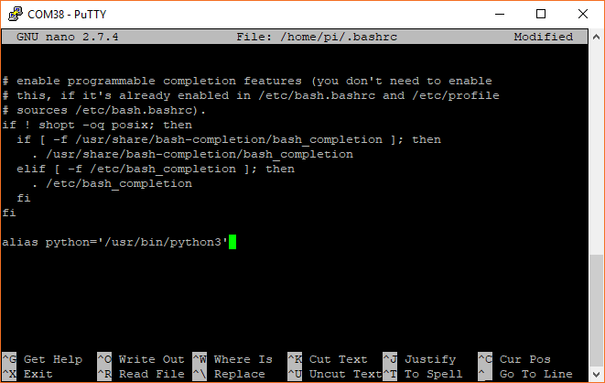](https://cdn.sparkfun.com/assets/learn_tutorials/7/8/3/terminal_10.png)

Exit out of *nano* by pressing *ctrl+x*, press the *y* key when prompted if you want to save the file, and press the *enter* key.

Instead of logging out and logging back in again to run the new command, you can simply run the contents of the .bashrc script by entering:

source ~/.bashrc

Now, check the version of Python again:

python **--**version

You should see some version of Python 3 being used.

[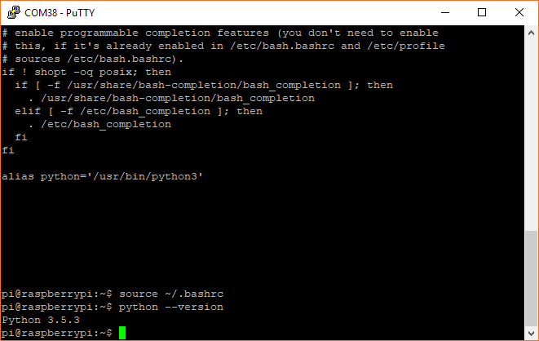](https://cdn.sparkfun.com/assets/learn_tutorials/7/8/3/terminal_11.png)

Install pip

**Full Desktop:** If you are using the full desktop version of Raspbian, you should have *pip* already installed.

**Headless:** If you are using Raspbian Lite, the Python package manager, *pip*, does not come pre-installed. As a result, you will need to install it with the commands:

sudo apt**-**get update

sudo apt**-**get install python3**-**pip

Press *y* when prompted.

Note that to use pip for Python 3, you will need to use the command pip3. However, we can modify the .bashrc file to use *pip* instead of *pip3*, as the rest of the tutorial will show examples using *pip*:

nano ~/.bashrc

Scroll down to the bottom, and add the following command to the file:

alias pip**=**pip3

[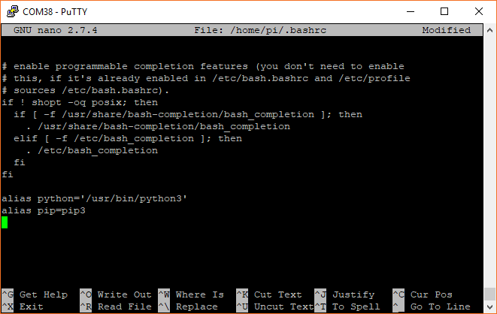](https://cdn.sparkfun.com/assets/learn_tutorials/7/8/3/terminal_15.png)

Exit out of *nano* with *ctrl+x*, press *y* and *enter*. Run the .bashrc script with:

source ~/.bashrc

You should now be able to install Python packages using the *pip* command.